Table 1: Vertebrate steroids in crustacean having a role in ovarian maturation:
Steroids | Species | Techniques to study the hormonal effect | Organs taken for analysis | Criteria used in functional implication | References
Estradiol (E2) and progesterone (PG) | Penaeus monodon | Enzyme Linked Immunosorbent Assay (ELISA) | Hemolymph, ovary and hepatopancreas | Relatively higher level of E2 and PG found in hepatopancreas at all ovarian stages. | Merlin et al., 2016
 |  | Histology & Immunohisto chemistry | Ovary | Estrogen receptor and progesterone receptor protein signals found in pre-vitellogenic oocytes of immature ovary
17β-Estradiol(E2)  &  Progesterone(PG) | Oziothelphusa senex senex | Histological studies | Previtellogenic ovary | Ovarian index and oocyte diameter increased after injection. | Swetha et al., 2016
 |  | ELISA | Previtellogenic ovary | Ovarian vitellin level increased after injection.
 |  | RT-PCR | Hepatopancreas,  Previtellogenic ovary | 1. Vg mRNA level in the hepatopancreas found increased after injection.  2. mRNA level of ecdystone receptor(EcR) and retinoid receptor increased in hepatopancreas and ovary after injection.
 |  | In-silico analysis | Previtellogenic ovary | Interaction between E2, PG and ecdysteroid receptor suggests the mediation of EcR in inducing vitellogenesis after injection.
17α-hydroxy progesterone (17α -OHP) and 17α-hydroxy pregnenolone (17α -OHPL) | Scylla olivacea | Histological studies | Immature crab in intermolt stage | Crab injected with 17α –OHPL showed highest Gonad somatic index(GSI) and large oocytes compared with 17α –OHP | Muhd-Farouk et al., 2015
17β-Estradiol(E2)  17α-hydroxy progesterone (17α -OHP) | Penaeus monodon | Histological analysis | Immature(white) immature(Yellow) Vitellogenic ovary | E2 exposure in culture facilitates oocyte enlargement | Merlin et al., 2015
 |  |  | Immature(white), Vitellogenic ovary | 17α –OHP in culture facilitates oocyte enlargement
 |  | RT-PCR | Immature (Yellow) | E2 in culture stimulates Vitellogenin(Vg) mRNA synthesis
 |  |  | Vitellogenic ovary | 17α –OHP in culture stimulates Vg mRNA synthesis
 |  | Gonadosomatic index (GSI) | Immature ovary | E2 and 17α –OHP treatment along with eyestalk ablation resulted in higher GSI
 |  | RT-PCR | Immature ovary | Vg mRNA transcript level found higher for the animal which injected with both 17α –OHP and eyestalk ablation
 |  | Western blotting | Immature(white), immature (Yellow), Vitellogenic ovary | Estrogen receptor (ER) and progesterone receptor(PR) expression in the ovary
17α-Hydroxy-Progesterone | Neohelice granulata | Gonadosomatic index | Post-reproductive period ovary | Gonadosomatic index increased significantly in females fed with pelleted feed. | Medesani et al., 2015
 |  | ELISA | Post-reproductive period ovary | Vitellogenic proteins (Vg) content in the ovary found increased after feeding with pelleted feed.
 |  | Protein synthesis assay | Post-reproductive period ovary | Ovarian protein level in culture found increased.
 |  | Vitellogenic protein concentration assay | Post-reproductive period ovary | Vitellogenic proteins (Vg) content in the cultured ovary increased.
17β-oestradiol (E2) and 17 α –hydroxy progesterone (PG) | Astacus  leptodactylus | Radioimmunoassay (RIA) | Hemolymph, ovary and hepatopancreas | E2 level increased in the haemolymph, ovary and decreased in the hepatopancreas during vitellogenesis,  PG level enhanced in hemolymph and ovary during maturation stage. | Malati et al., 2013
17β-Estradiol(E2)  Progesterone(PG) | Cherax albidus | Histological analysis | Hepatopancreas | Hepatopancreas morphology changed during early and late vitellogenic females after injection.  Increase in the size of the hepatopancreatic cells mainly due to the presence of large lipid vacuoles. | Coccia et al., 2010
 |  | Immunohistochemistry | Hepatopancreas | In Early vitellogenic females, Vtg immunoreactivity found in the vacuoles of some epithelial cells after injection.
 |  | RT-PCR | Hepatopancreas | E2 found to be more effective than progesterone on Vtg mRNA synthesis in the hepatopancreas after injection.
 |  | Western blotting | Hemolymph | PG was more effective than E2 and E2 plus PG in increasing the vitellogenin concentration in the hemolymph of Early vitellogenic and Full vitellogenic females under injection.
Progesterone (PG) | Scylla paramamosain | ELISA | Hemolymph, ovary and hepatopancreas | Peak levels of PG detected during previtellogenic stage in hemolymph, ovary, and hepatopancreas.  PG level decreased significantly in vitellogenic stage I.  During vitellogenic stage II, progesterone levels rose again in the hemolymph and ovary, but continued to decrease in the hepatopancreas. | Ye et al., 2010
 |  | Western blotting | Ovary | Progesterone receptor identified in vitellogenic ovary I & II
 |  | Immunohistochemistry | Ovary | PR was detected mainly in the follicle cells during vitellogenic stage I and in the nuclei of oocytes in vitellogenic stage II.
17β-estradiol E2), testosterone (T) and 17α -hydroxy progesterone  (17-OHP; conjugated and unconjugated) | Macrobrachium rosenbergii | Solid-phase radioimmunoassay (RIA) | Hemolymph, ovary and hepatopancreas | High levels of unconjugated 17-OHP, relatively constant concentrations of unconjugated T, and null concentration of unconjugated E2 were found in the hemolymph, throughout the five stages of ovary. | Martins et al., 2007
17β-Estradiol (E2) | Marsupenaeus japonicus | Histological studies | Previtellogenic (immature) ovary | E2 in culture induces the appearance of primary vitellogenic oocytes in the immature ovary. | Yano and Hoshino, 2006
 |  | Rocket immunoelectrophorsis | Previtellogenic (immature) ovary | Induction of Vg synthesis and secretion in the immature ovary under cultured condition.
Estradiol-17β(E2) and Progesterone  (PG) | Emerita asiatica & Macrobrachium rosenbergii | Radioimmunoassay (RIA) | Hemolymph | E2 and PG level found high in crabs with mature ovaries. | Gunamalai et al., 2006
 |  |  | Ovary, Hepatopancreas, Hemolymph | During the reproductive molt cycle of Macrobrachium rosenbergii, the level of E2 and PG in all tissues peaked during intermolt, but declined drastically at premolt and postmolt stages.  The level of E2 and PG in hemolymph was not detectable in any molt stage during the non-reproductive molt with the ovary containing undeveloped oocytes.
Progesterone and Estradiol receptors (PR and ER) | Austropotamobius pallipes | Immunohistochemistry and western blotting | Ovary, hepatopancreas | ER found in the hepatopancreas and PR found in both the hepatopancreas and ovary after injection. | Paolucci et al., 2002
17β-Estradiol(E2)  Progesterone(PG) | Scylla serrata | Radioimmunoassay (RIA) | Ovary, hepatopancreas and hemolymph | E2 is high in hepatopancreas and PG is maximal in ovary during vitellogenic stage I. | Warrier et al. (2001)
17β-Estradiol(E2) | Macrobrachium rosenbergii | Enzyme assay | Ovary, hepatopancreas | The activity of 17 β –hydroxysteroid dehydrogenase, a key enzyme in steroid metabolism, increased after injection. | Ghosh and Ray, 1993
 |  | Radioimmunoassay | Hemolymph, ovary | E2 level in the maturing prawn increased after injection.
Progesterone- and  Estradiol-17 β ~like substances | Pandalus kessleri | Histological studies | Ovary and hepatopancreas | GSI, HSI significantly increased when ovaries were composed of yolky oocytes and decreased sharply after spawning. | Quinitio et al., 1991
 |  | Radioimmunoassay (RIA) | Hemolymph | Progesterone level found increased at the onset of vitellogenesis and decreased during vitellogenesis.  Estradiol concentrations rose during the peak of vitellogenesis.
Estradiol 17β(E2) and  Progesterone(PG) | Homarus americanus | Radioimmunoassay | Mandibular organ, green gland, hepatopancreas,  ovary and serum | E2 and PG found undetectable in all tissues of animals possessing immature ovaries, except in the mandibular organ.  PG concentration was almost identical in mandibular organs of all animals with developing ovaries. | Couch et al., 1987
17 α -Hydroxy-Progesterone | Penaeus  japonicus | Rocket immunoelectrophorsis | Early vitellogenic ovary | Stimulation of vitellogenin synthesis and release into the hemolymph after injection. | Yano, 1987

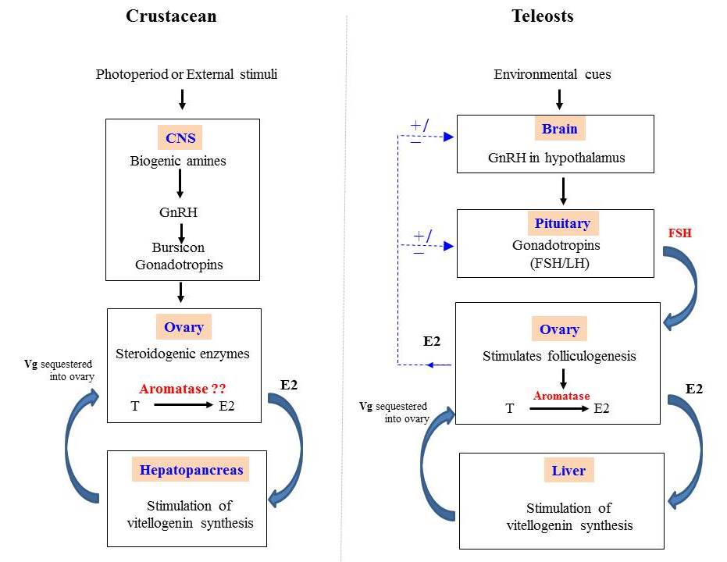
Fig. 1. Role of steroids on vitellogenesis

Fig. 1. Schematic graphical diagram of the pathway regulating vitellogenesis in crustaceans and teleosts. CNS- central nervous system; GnRH-Gonadotropin-releasing hormone ; T-Testosterone; E2- 17β Estradiol; Vg- vitellogenin; ± - feedback; FSH-follicle stimulating hormone; LH-luteinizing hormone (Reproduced from Subramoniam, 2016).

